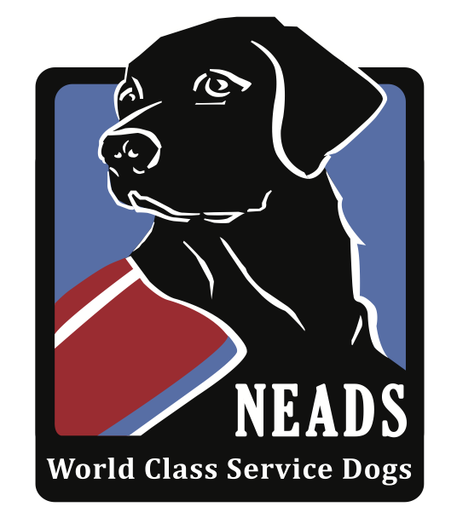
Naomi Ridge
Address
City, State & Zip

Dear

My name is Naomi Ridge, and I have been a Watertown resident for over 10 years. I was diagnosed with Multiple Sclerosis in 2015, and now use a wheelchair outside of my home. In the summer of 2017 I had to give up a career I loved, teaching college math and physics, due to the progression of my disease, and I now struggle to get out of the house without assistance. I have two young sons, ages 10 and 13, who I often have to ask for help in the kitchen and around the home.

I have applied to NEADS for a Service Dog to help me in these everyday activities. The dog can assist me by picking up things that I drop, flipping light switches, opening doors, helping me if I fall, or getting help when needed. My service dog will be able to carry things for me in a special backpack. In addition, my NEADS dog will be my 24-hour companion, and accompany me as I go about my daily activities. I hope to be able to reclaim my independence, and start volunteering at the Cunniff Elementary School which both my sons attended, or at the Watertown Public Library. Having a service dog will give me the confidence to go out and achieve goals which have been put on hold due to my disease and disability.

NEADS Service Dogs spend up to two years in training to learn these vital skills. When NEADS has trained a dog that is a good match for my personality, lifestyle, and assistive needs, I will travel to the NEADS campus in Princeton, MA and live there for two weeks to learn how to work with my new service dog.

The true cost of all the specialized training is over $45,000. As a client, I have pledged to raise $8000 for NEADS, which will allow them to continue to train and place these highly skilled dogs. Would you consider making a tax-deductible donation to NEADS to help me reach my fundraising goal? Gifts of all sizes will be greatly appreciated. Donations can be made using the enclosed envelope, or online at https://neads.org/naomi-ridge/ .

When I return home with my service dog, I would be happy to meet with you or speak to your business. All sponsors are invited to attend our graduation – a unique and heartwarming event which occurs twice each year.

Thank you in advance for your kind consideration. Please do not hesitate to contact me with any questions.

Sincerely,

Naomi Ridge
--
Phone #
Email address

